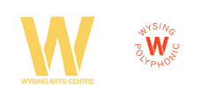
OPAQUE POETICS: WYSING ARTS CENTRE MUSIC FESTIVAL 2017 - CURATOR AND INITIAL LINE UP ANNOUNCED

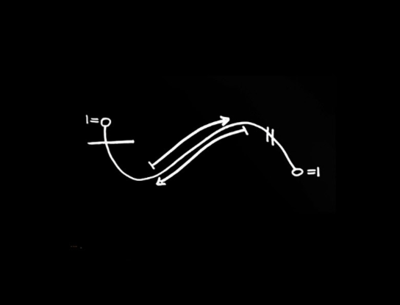

Wysing Arts Centre are pleased to announce the first wave of artists for their annual music festival, taking place this year on Saturday 2 September, as:
Angel-Ho / Abyss X / clubcouture with special guests / Felix Lee / John T Gast / Kamixlo / Klein / Naee Roberts / Nídia / patten / terribilis / Tribe of Colin
The 2017 art and music festival, Opaque Poetics, is curated by artist, music producer and DJ, Nkisi, who will also be playing live, and is the 8th music festival to take place at Wysing. The festival runs from 1pm to 1am.
The precisely curated lineup of some of the most influential and exciting artists, musicians and producers of their generation touches on genres including ambient, techno, industrial and soul. Each act has been given space on the programme to create immersive and intense soundscapes that will take the audience on a journey across 12 hours.
Nkisi - Melika Ngombe Kolongo - is a founding member of NON, a collective of African artists, and of the diaspora, who use sound as their primary media, to articulate the visible and invisible structures that create binaries in society, and in turn distribute power.
“Nkisi makes objects, not tracks. Her music is densely layered and tightly crafted. Its rhythms whorl, its textures mutate. Existing in a state of constant change, these objects shape and reshape themselves, drawing heterogenous sounds and syncopations into their orbits, like nails driven into wood.” Tiny Mix Tapes
Donna Lynas, Wysing’s Director and curator of previous Wysing festivals said:
“This is our eighth music festival at Wysing and only the second to be conceptualised and curated by an invited contributor. The relationship with Nkisi came about through her playing at Wysing in September last year and I am thrilled to be working with her again on the festival. She has pulled together a stunning line-up; one of great clarity and precision.”
Early Bird tickets are available until 1 July 2017 via Eventbrite, click here for £15. Price thereafter £25 for a day pass.
More announcements to the line-up will be made over the coming weeks including a number of visual artsts who are contributing to an ambitious installation conceived by Curtly Thomas of clubcouture.
ENDS

For press information contact Nicola Jeffs – nicolajeffspr@gmail.com / 07794694754
Wysing Arts Centre is just an hour from London. Complimentary return travel from London is available for journalists reviewing the festival.
Wysing Arts Centre, established in 1989, develops new ways to support artists and enables art and ideas to engage a wide range of people in unexpected ways. Wysing’s large rural site near Cambridge comprises artists’ studios, a gallery and project spaces, a 17th century farmhouse and outdoor sculptures and structures. In the summer of 2017 a recording studio is being added to the site www.wysingartscentre.org
This year, Wysing are exploring ‘many voices’ in all aspects of programming. Across the year Wysing are working with a range of artists to explore a diversity of contexts and positions to help better understand the role of art, artists, and arts organisations such as Wysing, at this moment of global political change.
Nkisi: https://soundcloud.com/nkisi
Twitter @wysingartscentre I Facebook Wysing Arts Centre I Instagram @wysing_donna #wysingpolyphonic #opaquepoetics

