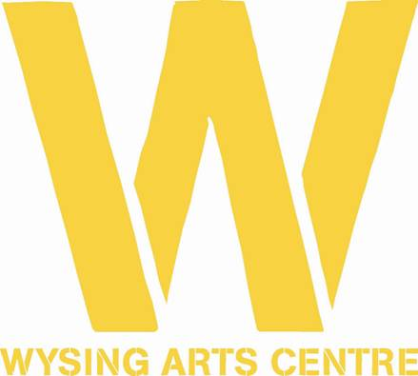

PRESS RELEASE

Donna Lynas, Director of Wysing Arts Centre in Cambridgeshire, recognised in the Queen’s Birthday Honours List 2020

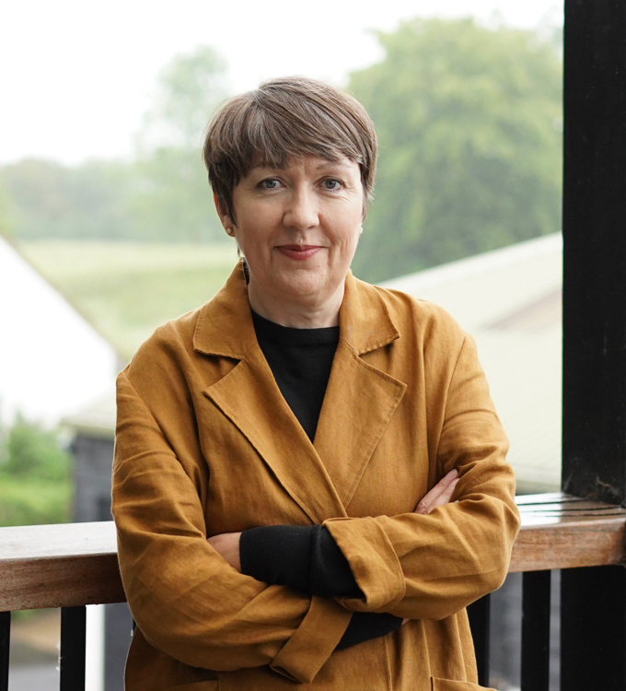

Donna Lynas, Director of Wysing Arts Centre in Cambridgeshire has been honoured with an MBE for Services to the Arts in the Queen’s Birthday Honours List 2020. With artist studios, a gallery, a music recording studio, educational and project spaces, and extensive outdoor areas, Lynas has, over the past fifteen years, established Wysing as a centre for innovation and experimentation, and for the creation and presentation of new contemporary visual art, music and dance.

Lynas said, “For me, this Honour recognises the work that everyone at Wysing has done, and continues to do, to address some of the barriers and inequalities that exist within contemporary society, and the important contribution that artists and the arts make in raising these issues with wider audiences.”

Chair of Wysing, Jo Marsh said, “Donna has pioneered a visionary strategic direction for Wysing, creating openness and inclusion for all, and something extraordinary is flourishing there. You can’t create those conditions overnight, and for years Donna has been listening, iterating and building, driven by her deeply held commitment and understanding of the benefits of artists to our society.”

Sir Nicholas Serota, Chair, Arts Council England said, “At Wysing, Donna has created a unique centre that has given artists an opportunity to develop their work and audiences the opportunity to engage with art as it is being made. I am delighted that her contribution over many years has been given wider public recognition.”

Lynas has been director of Wysing Arts Centre since 2005, developing it as a research centre for the visual arts, and introducing experimental artists' residencies and retreats, and commissioning and curating ambitious commissions and projects including Wysing Polyphonic, the acclaimed annual festival of art and music. In 2018, she initiated a re-scoping of Wysing’s programme and infrastructure to enable artists with disabilities and caring responsibilities to undertake residencies. In 2016, she led a consortium of organisations to deliver New Geographies, a three-year programme across the East of England, which included MOTHER, Studio Morison’s extraordinary hayrick sculpture for Wicken Fen in 2020. In 2015, Lynas established Syllabus, an alternative learning programme with four other national arts organisations, which has so far supported nearly 200 artists and contributors. In 2014, Lynas radically changed the positioning of the annual music festival, so that year it foregrounded the work of women and non-binary performers.
Prior to Wysing, Lynas was Curator at South London Gallery, where she established an influential performance and off-site programme, and worked with leading international artists on solo exhibitions. Before this she was Curator (1997-99) and Touring Exhibitions Manager (1995-1997) at Modern Art Oxford.
In recent years, Lynas has worked to ensure that Wysing provides a platform for diverse voices; amplifying and celebrating artists’ whose voices have been previously under-represented, including those addressing issues of race, gender, sexuality, accessibility and disability in their work and lives. She has taken a leading role in developing plans and strategies to diversify the Plus Tate network of visual arts organisations, and she is Chair of the Contemporary Visual Arts Network in the East of England She contributes to international conferences and publications on how institutions can better support and give agency to artists.

For interview and image requests, and further information please contact Janette Scott Arts PR on janette@janettescottartspr.com, or 07966 486156.

Notes To Editors

About Donna Lynas
Donna Lynas (born 1967, N. Ireland) has been Director of Wysing Arts Centre since 2005 and has developed Wysing's identity as a research centre for the visual arts; introducing experimental artists' residencies and retreats and commissioning and curating ambitious commissions and projects including Wysing’s annual festival of art and music. She leads the programme team and shapes the emphasis of Wysing's artistic activity and identity, alongside developing organisational priorities.
Donna plays an active role on the steering committee of the Plus Tate network of Directors and in recent years has taken a leading role in developing plans and strategies to diversify the network. Donna is Chair of the Contemporary Visual Arts Network in the East of England and leads the region-wide programme New Geographies which over three years has commissioned new work to be created within regional communities. She has contributed to international conferences and publications over many years on how institutions can better support and give agency to artists.
Previously, Donna was Curator at South London Gallery (1999-2005) where she established the gallery’s influential performance and off-site programmes and worked with artists including Christian Boltanski, On Kawara, Joëlle Tuerlinckx and Steve McQueen on their solo exhibitions, alongside curating a number of group exhibitions.
Prior to that, Donna was Curator (1997-99) and Touring Exhibitions Organiser (1995-1997) at Modern Art Oxford. She was part of the exhibitions team led by Curator Chrissie Iles that delivered key MAO exhibitions including solo exhibitions by Marina Abramović, Louise Bourgeois, Gustav Metzger and Yoko Ono. Before joining MAO, Donna studied at Duncan of Jordanstone College of Art, Dundee and worked from artist studios in Dundee and Reading.

About Wysing Arts Centre
Wysing Arts Centre was established in 1989 and its large site in rural Cambridgeshire encompasses artist studios, a large gallery, a music recording studio, educational and project spaces, onsite accommodation, ceramics facilities, and outdoor space with sculpture. Through its innovative work, Wysing influences the development of the visual arts sector in the UK. As a respected and well-connected institution operating outside the usual gallery system and urban context, Wysing is uniquely positioned to develop programmes that provide opportunities for the exchange of knowledge and ideas, and which reflect on the role of art, artists, and arts organisations in society; acting as a testing ground for new ideas.

Wysing Arts Centre is an Arts Council National Portfolio organisation, and in its last four assessments was rated “outstanding” for its creative case for diversity. For more data on this, please contact us. www.wysingartscentre.org

