2020 Programme Launch Access Information

TRANSPORT
There are three available transport options for the Programme Launch:
All Day: from Cambridge Station to Wicken Fen, and then on to Wysing, returning to Cambridge Station.
Afternoon Only: return transport from Cambridge Station to Wicken Fen.
Evening Only: return transport from Cambridge Station to Wysing.

All Day transport option will be via coach. The coach organised from Cambridge to Wicken Fen, and then on to Wysing, is not wheelchair accessible.

Transport from Cambridge to Wysing (Evening Only option), and from Wicken Fen to Cambridge (Afternoon Only option) will be via taxi. These taxis are not wheelchair accessible.

WICKEN FEN
Studio Morison, ‘MOTHER...’
2-4pm

ACCESSING ‘MOTHER...’ FROM WICKEN FEN CAR PARK
Wicken Fen’s accessibility statement reads: “Please note that unfortunately the paths leading to MOTHER... at Wicken Fen are uneven and very muddy in places at the moment due to recent weather, so are not suitable for wheelchairs or scooters. There are disabled car parking spaces in the car park on Lode Lane”.

To reach MOTHER... there is a fifteen-minute walk across uneven, muddy ground, followed by a 50 metre walk along a raised wood-plank bridge. MOTHER... then sits on a slight upwards incline, after a further 50 metres of uneven ground.

Wysing staff will be leading groups from the car park to MOTHER....

MOTHER... ACCESSIBILITY
The interior of MOTHER... is accessed through three narrow doors, each of which has two steep steps leading inside, and so there is no step-free access.

The structure is dimly lit inside by natural light through its doors. The interior of the structure is medium-sized, and will be busy during the launch event. The launch event will take place inside the structure, and will be accompanied by music.

WYSING ARTS CENTRE
Naomi Harwin, ‘Encounter’, and Helen Cammock, ‘They Call It Idlewild’
5-7pm

ACCESSING THE GALLERY SPACES
Both exhibitions at Wysing—Helen Cammock’s ‘They Call It Idlewild’, and Naomi Harwin’s ‘Encounter’—have step-free access. There are accessible car-parking spaces at Wysing, with step-free access to the Reception, where the main gallery space is located, and the Test Space gallery. This is across a lightly-gravelled, level courtyard. The courtyard is dimly lit.

Signage will be provided, highlighting step-free routes, the gallery spaces being used, and directions to accessible toilets. Maps of the site will also be provided.

Main Gallery Space
To access the main gallery space, there is a ramp with hand-rails up to the Reception doors from the courtyard. From here, access to the main gallery space, where ‘They Call It Idlewild’ is exhibited, through Reception, is step-free on even, level concrete floor.

There are two sets of manual doors to access the main gallery space from outside: one from outside to Reception, and another from Reception to the main gallery space. These doors are heavy, but staff will be available to assist.

On entering the main gallery, there is a low, upwards, concrete incline from the gallery doors to the main gallery space. The main gallery space is even and carpeted. There are four sets of wide, cushioned, backed seats installed in the gallery, and space for wheelchairs.

Test Space Gallery
Naomi Harwin’s exhibition is held in our Test Space gallery. Access to this space is step-free, across a lightly-gravelled courtyard from both the main gallery space, and from the accessible parking spaces. The Test Space gallery is accessed through a heavy manual door, but staff will be available to assist. The Test Space is brightly lit, with warm pink light.

Reception
The Reception is brightly lit and spacious. It will be a gathering area during the launch, and so will be busy throughout the event. A quiet space will be available next to the Test Space gallery for the launch, and signposted.

Foldable stools are provided in Reception, and there is also foldable chair seating at low tables in the main Reception area, with backs and no arm rests.

We do not have hearing loops installed onsite.

ARTWORKS
Helen Cammock’s exhibition is a 17-minute film-work, and so the main gallery will have low light-levels and a medium-level audio soundtrack. The film is presented without subtitles. A transcription of the film will be available. This transcription will also be available in large-print format.

The Test Space, where ‘Encounter’ is exhibited, is an installation in a small space, with sculptures installed on the floor and across the walls, and will likely be busy during the opening. There is low contrast between sculptures and the floor.

Large-print exhibition information will be available at Reception. The Reception desk has a lowered area immediately visible when entering through the Reception door.

TOILETS
There are two accessible toilets onsite. Both will be visibly signposted.
There is one accessible toilet available in the main Reception area.
There is another accessible toilet available next to the Test Space gallery.

DOOR WIDTHS
The door to enter Reception is 1 metre wide.
The door to the main gallery space is 95cm wide.
The door to the accessible toilet in Reception is 95cm wide.
The door to the Test Space gallery is 92cm wide.
The door to the accessible toilet by the Test Space gallery is 90cm wide.
The door to the quiet space is 1m 5cm.

Please email our Head of Operations, Ceri Littlechild, on ceri.littlechild@wysingartscentre.org with any additional questions, or any feedback on our accessibility information.
IMAGES
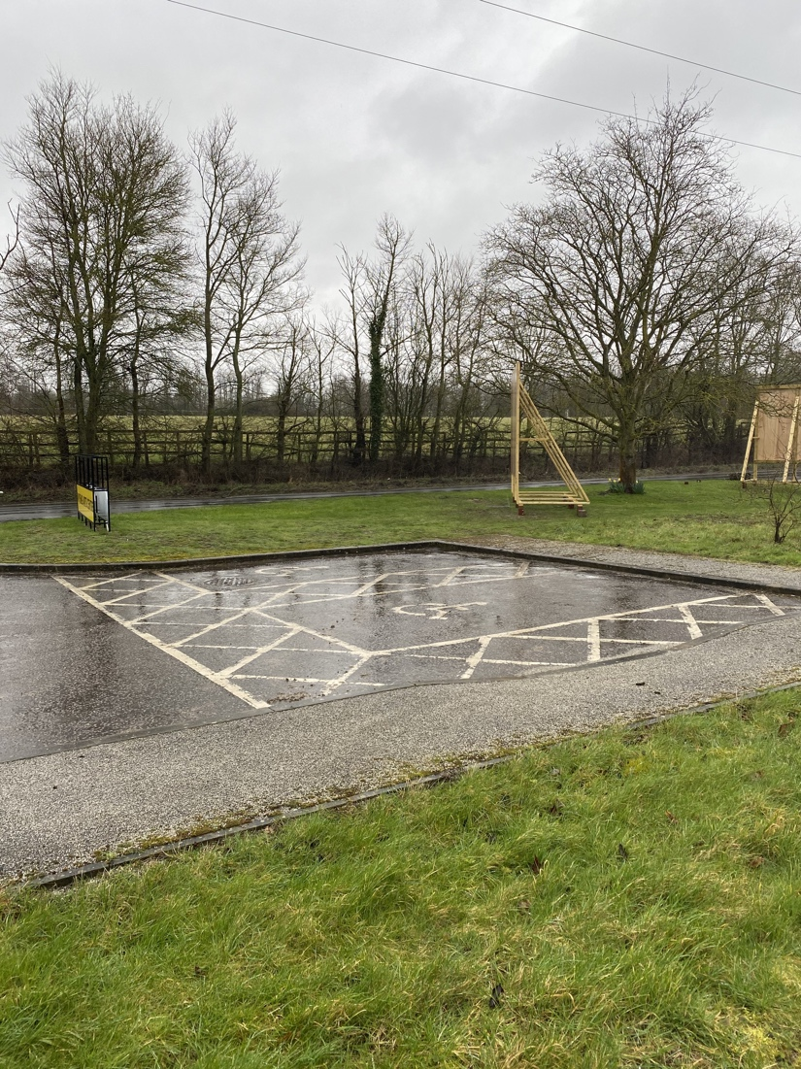
Accessible parking spaces.

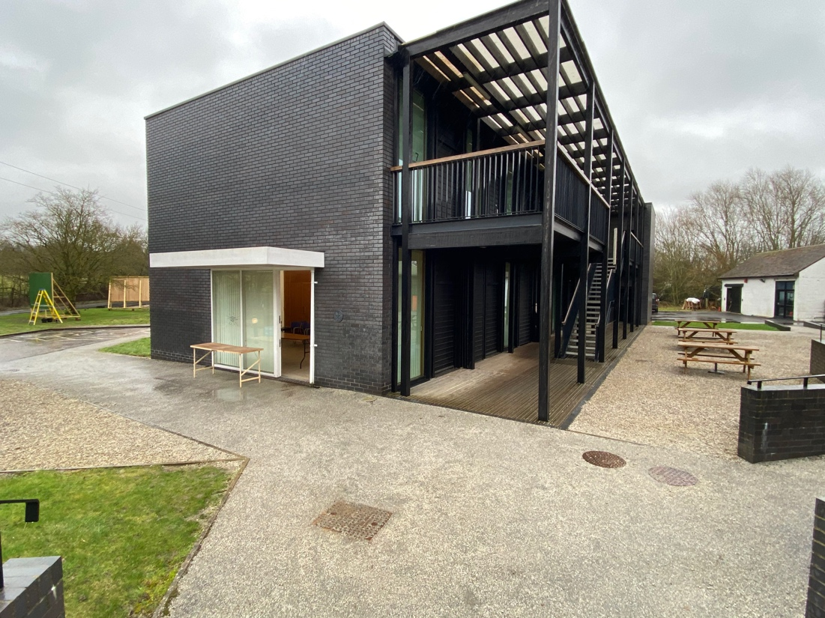

Courtyard viewed from Reception. The building visible is the Studio Block which contains the Test Space gallery and Quiet Space.

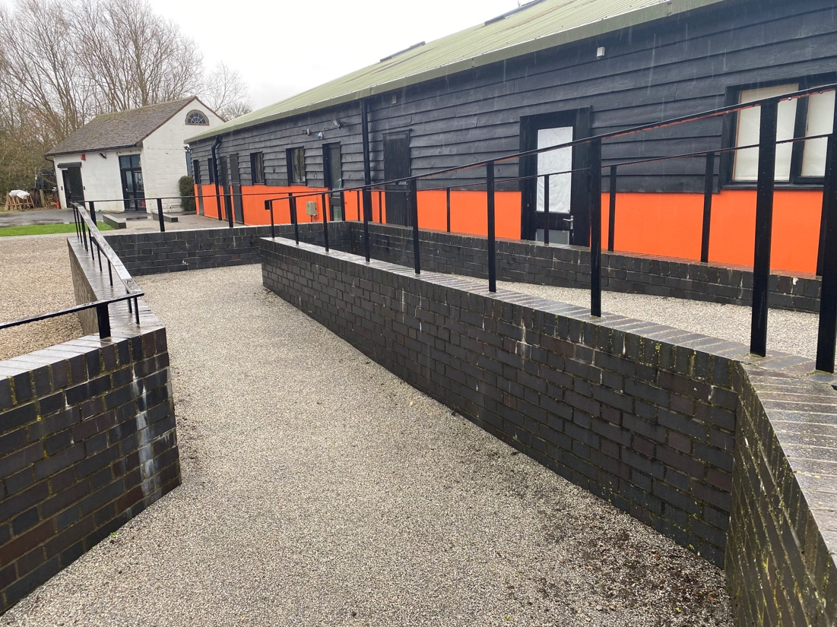
Ramp to Reception from Courtyard.

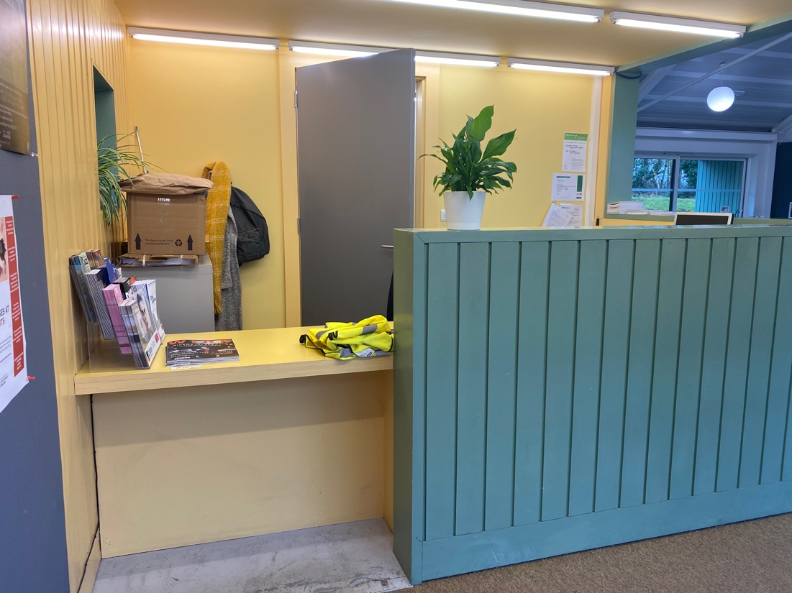
Lowered area of Reception Desk.

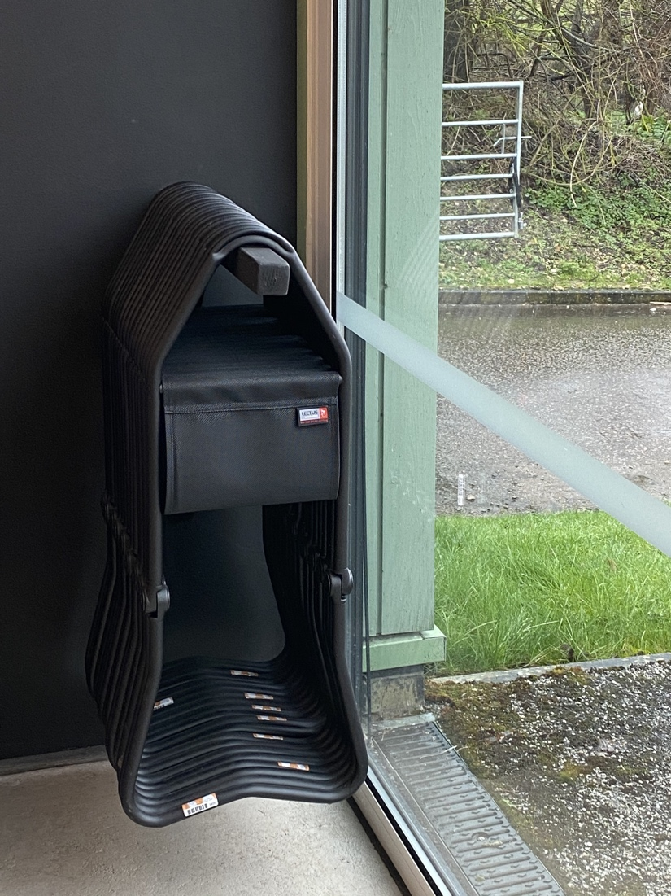
Foldable stools available in Reception.

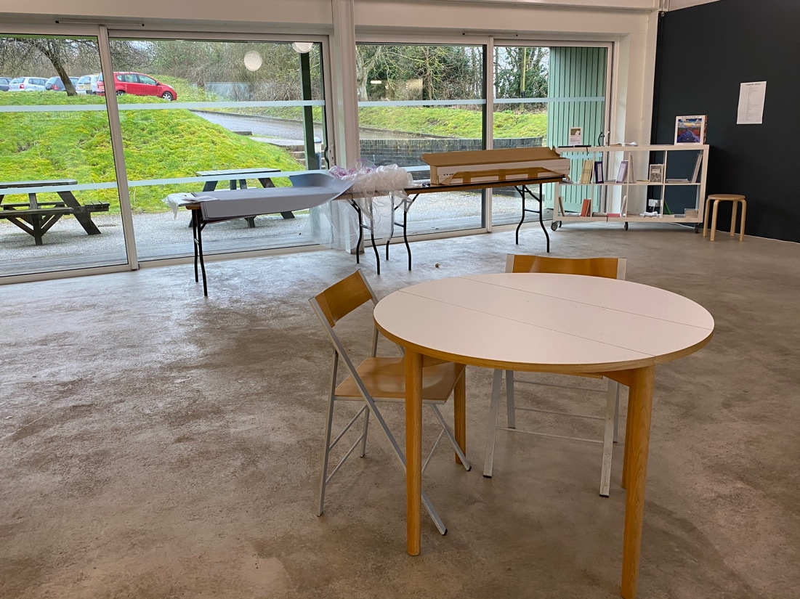
Folded chairs and low tables in Reception.

