PRESS RELEASE

Wysing Arts Centre to work with OEB Architects on a £500k development of their eleven-acre site in rural Cambridgeshire

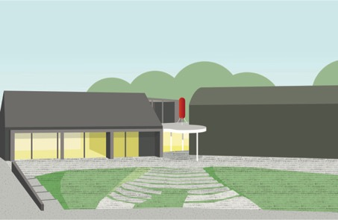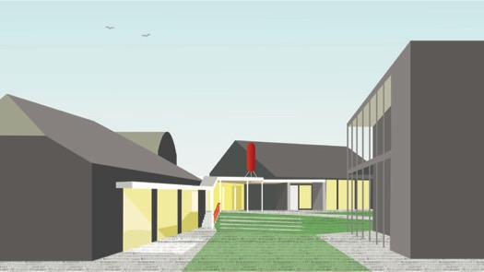

Wysing Arts Centre is working with OEB Architects on an ambitious £500k development of their eleven-acre site in rural Cambridgeshire to improve accessibility and environmental sustainability for future generations. Initial plans include a pavilion that will form a focal point for visitors, and a reconfiguration of spaces to increase natural light and flexibility of use. As part of their approach, OEB Architects will spend a short time in residence at Wysing - reflecting the way that artists also use the space - to evolve their initial ideas into final plans.

OEB Architects said “We are very excited to be working with Wysing on its next phase of works, with an approach of focused alterations and additions that help to improve the access, usability and sustainability of the site. We aim to balance the need for adaptable and undetermined spaces with legibility and connection between the different elements, making the most of the character of what already exists."

Director of Wysing Arts Centre, Donna Lynas, said “Wysing has hosted many artists over the past 30 years and welcomed many thousands of visitors. Some of the most exciting art in the UK is being made right here and our buildings need to be able to support that level of working. We hope that donors and sponsors will want to come on board to help us shape these exciting changes that will set Wysing up for the next 30 years.”

Wysing received forty-six tenders for the new development from architectural practices, including Cooke Fawcett, Manalo & White and OEB Architects taken forward to the final stage of recruitment.

Wysing Arts Centre - which celebrated its 30th anniversary in 2019 - is a pioneering workplace for art and artists encompassing artist studios, a large gallery, a music recording studio, educational and project spaces, onsite accommodation, ceramics facilities, and an extensive outdoor space with sculptural works. In February 2020, Wysing launched They Call It Idlewild, a new commission by Turner Prize winner Helen Cammock, and MOTHER… a site-specific installation by Studio Morison for Wicken Fen. Through its innovative work, Wysing influences the development of the visual arts in the UK and beyond, with hundreds of artists travelling from across the globe to take part in programmes each year.

For images, interview requests and further information please contact Janette Scott Arts PR on janette@janettescottartspr.com, or 07966 486156.

NOTES TO EDITORS

About OEB Architects
OEB architects was formed in 2018 by Tessa Baird and David Eland to make work of imagination and social good, building on their combined experience in architecture, teaching, and construction. The directors have previously worked for a number of well- respected practices in London, gaining extensive experience of adaptive reuse projects in sensitive historic environments for both private and public sector clients. As students David and Tessa were founding members of self-build collective and Scottish Charity ‘Voluntary Design and Build’ which designed, fundraised, and constructed a series of timber framed buildings the UK and Central Europe. https://www.oebarchitects.co.uk/

About Wysing Arts Centre
Wysing Arts Centre was established in 1989 and its large site in rural Cambridgeshire encompasses artist studios, a large gallery, a music recording studio, educational and project spaces, onsite accommodation, ceramics facilities, and outdoor space with sculpture. Through its innovative work, Wysing influences the development of the visual arts sector in the UK. As a respected and well-connected institution operating outside the usual gallery system and urban context, Wysing is uniquely positioned to develop programmes that provide opportunities for the exchange of knowledge and ideas, and which reflect on the role of art, artists, and arts organisations in society; acting as a testing ground for new ideas. www.wysingartscentre.org

